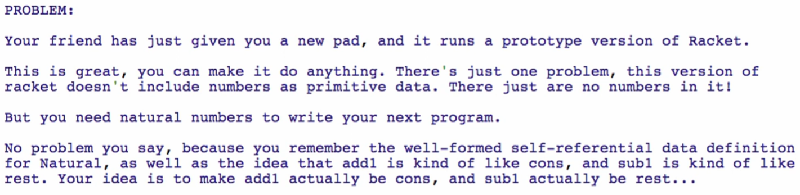

Data definition of NATURAL (our own definition of Natural)

1. Type comment

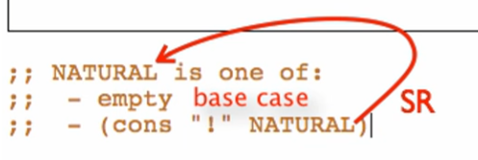

1. Interpretation



1. Examples

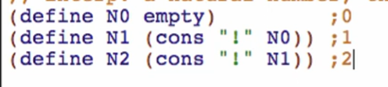

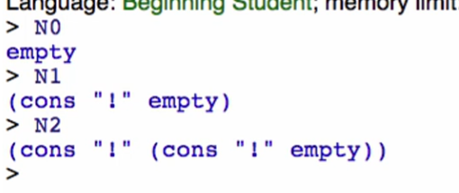

Adding more:

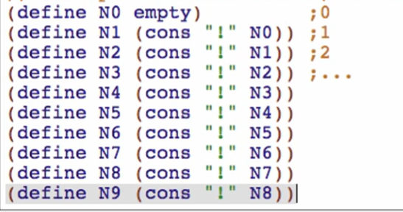

Defining our own primitives that we’ll use for our own NATURAL

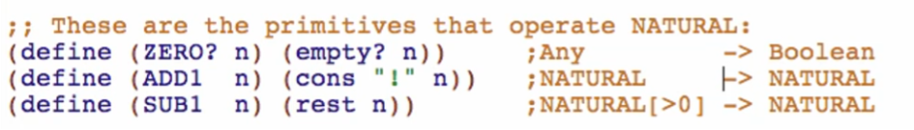

1. Template

One of 2 cases:

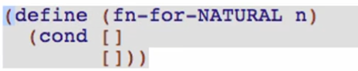

Case 1/base case: atomic distinct: ZERO

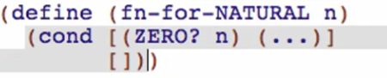

Case 2: compound 2 fields with self-reference (SUB1 n)

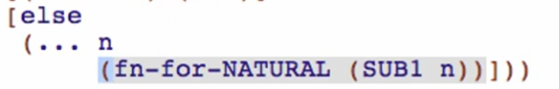

Making a function for **Adding 2 Naturals**:

Function definition

1. Signature, purpose, and stub

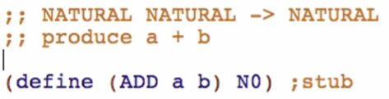

1. Examples

For base case: 2 scenarios -> one for each addend side

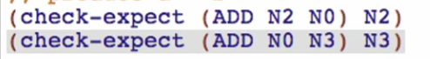

For other cases: at least 2 elements



1. Template

Copy template, rename the functions and natural recursion

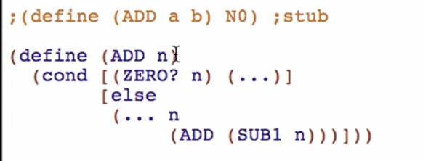

Renaming the parameters

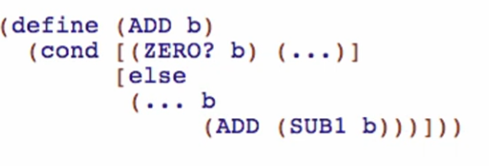

Then add the parameter a

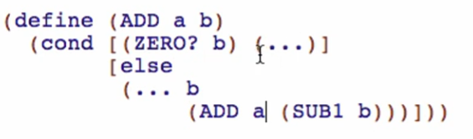

1. Code body

Base case result:

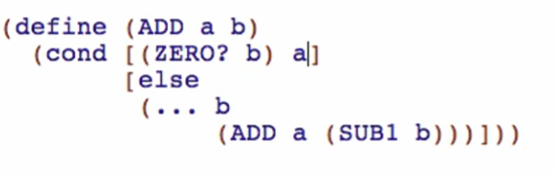

Other cases:

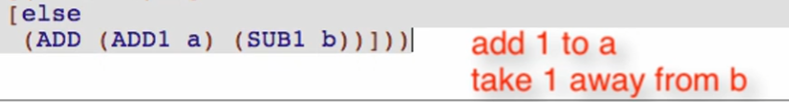

1. Test and debug

Making a function for **Subtracting 2 Naturals**:

1. Signature, purpose, stub

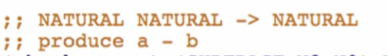



1. Examples

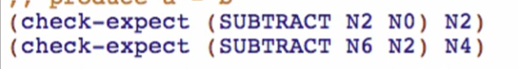

1. Template

Template from data definition

1. Code body

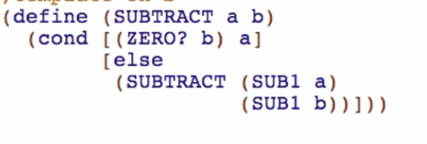

Base case:



Other case:

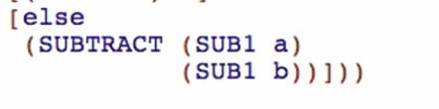

Other functions:

FACTORIAL

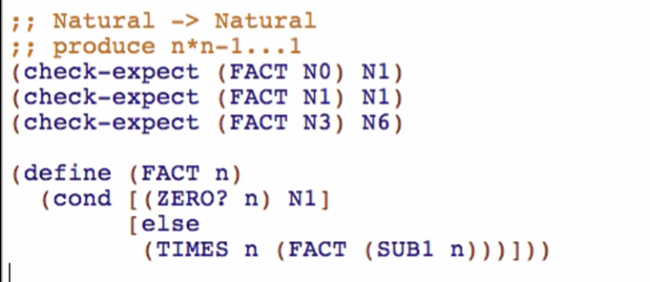

TIMES

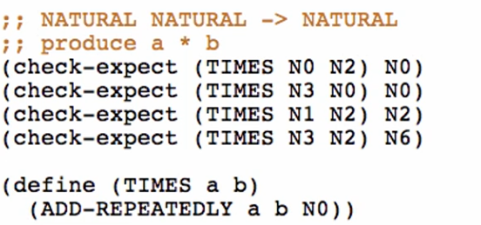

ADD-REPEATEDLY

